Secure Operating Systems
The fundamentals of OS design: Windows OS Analysis

Anonymous Student
School of Technology, Design, & Environment
Oxford Brookes University

Table of Contents
Secure Operating Systems 1
Abstract 1
Introduction 1
How OS supports and provides security features, reliability, and protection 2
Filesystem 2
Access control 2
Security descriptors 2
Privileges and audits 3
Encryption 3
Processes 3
Multiprogramming 4
I/O spooling and buffering 4
Comparing Windows to MacOS 4
Effects on application developers 5
Conclusion 6
Recommendations for hardening the system and OS file systems 6
Personal reflection 6

Abstract
A look at the security features provided through the Windows operating system file system and comparison to MacOS.

Introduction
Computers without software are of challenging use to humans; they are simply hardware: solid parts and data stored in a solid, electronic, or magnetic state. The software in computers allows data to be read in certain formats and processes to be performed. This software is split into two categories: system programs that manage the operation of the computer controlled by the kernel, and application programs which perform tasks for the human user. These will both use system calls to request service from the operating system’s kernel. The kernel being the master software managing all other software within the OS.
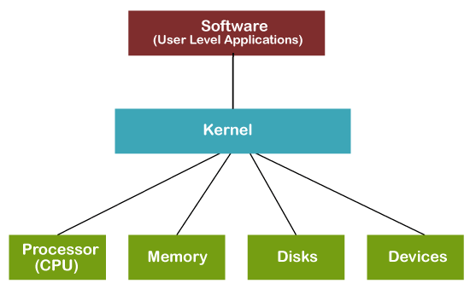Figure 1: Kernel diagram [1]

The operating system (OS) is a middle-man between the hardware and the user software, allowing communication through one to the other in an abstracted way. The user need not know about all the minute details of the hardware. The operating system is an interface that allows ease of use by displaying data on discs as graphical files, providing precoded methods to access the hardware and similar abstractions.

Windows provides the security features including: filesystem, access control, encryption, process management, multiprogramming, and data management.

How OS supports and provides security features, reliability, and protection

Filesystem
Windows supports optional security features for file systems and the operating system. There are different types of file systems that can be implemented, including: NTFS, FAT, CDFS, UDFS, TDBSS, and SMB. Other operating systems may have different types of file systems also. The OS preceding Windows, MS-DOS, used FAT (file allocation table). NTFS later superceded FAT on Windows. As of all file systems: the purpose is to store, organise, and find files on hard disks efficiently.

NTFS provides a number of security features including security descriptors, encryption, disk quotas, and rich metadata.

Resilient File System (ReFS) was introduced in Windows Server 2012 as a proprietary feature with the intention of replacing NTFS. It is more resilient as it can detect and fix corruption. Files can become corrupted during the saving process as if the computer shuts down during this process the file addresses will not have been properly written to the disk.

Access control
Access control manages which users can access resources in the operating system. This includes access tokens that contain information about a user, and security descriptors which contain security information about a securable object.

Pipes can be used to send data one-way between files or processes. The pipe is a pseudofile that will connect file A to file B, acting as an input file for A and an output file for B. On windows named pipes are stored in a hidden partition called the NPFS.

Security descriptors
Windows includes securable objects. These include all named windows objects and some unamed ones including processes and threads. These objects can have security descriptors, these contain all the security information associated with the object [1].

Files are protected with 9-bit binary protection code. This has three 3-bit fields, one detailing the owner, one for other member’s of the owner’s group, and one for everyone else. Each bit has a bit for read access, write access, and execute access, these are known as rwx bits [2]. An example might be ‘rwx--xr--’ meaning current user can read, write, execute, user group can execute only, and everyone else can only read. When a file is opened a file descriptor integer is returned or an error code if access is prohibited.

Disk mounting will attach the disk’s file system to a directory tree in the OS’ filesystem.

Privileges and audits
Users can have priviledges, these allow or restrict access to certain parts of the operating system. Such as a guest may not have read/write permissions but an administrator is able to change resources across all users. Custom user groups can be made to predefine groups of priviledges. Audits are created when users attempt to access resources, these serve as a log of all who have attempted to access a resource and can flag any suspicious behaviour.

Encryption
Encryption for individual files is provided using a public-key system through Encrypting File System (EFS). Which was first introduced in version 3.0 of NTFS.

EFS is used to protect files storing data from being accessed by unauthorised users. Folders or files can be marked for encryption and once the author closes a file it is then encrypted.

EFS uses public key encryption (transparent encryption). When a user requests to encrypt a folder EFS first uses Advanced Encryption Standard (AES) cipher to create a key which is then encrypted through an RSA algorithm to create an X.509 certificate. The certificate stores a generated private/public key pair. The public key of which is used to encrypt and the private to decrypt. The private key is stored in the user profile and may only be used by the user whom owns the certificate. Although the public key which encrypts the folder can be seen by anyone.

Processes
A process is a program in execution, it is associated with an address space which stores its stack, data, and executable. And a list of memory addresses that the process can read and write. It also includes a set of registers associated with the stack pointer, program counter, and other information.

Processes are what allow files to be READ and used. Scheduling algorithms are used so that while the CPU which can only run one process at a time, it will seem to the user as if it is running processes concurrently. Yet in reality it is sharing the time between each process by running each for a few milliseconds, suspending, and swapping between processes (context switch) running on the CPU. This means that if a process is reading a file it must save the state it was in, such as where the user had read up to, otherwise it would go back to the beginning. Thus this information (in the case of files these are pointers storing the byte number or record) must be saved somewhere and then READ. This is stored as an entry in the process table; which is an array or linkedlist for every process. And the address of the process is also stored seperately, known as a core image.

Processes are also used to communicate over a network. A process will send messages to another process on a different computer over a network. To make sure that messages are not lost if the sender process does not recieve an acknowledgement in a certain amount of seconds then the operating system will send a signal to inform the sender to retransmit the message. This signal will cause the process to suspend, save its registers to the stack and run a signal handling procedure such as retransmitting the message. These signals are the software equivalent of hardware interrupts.

Multiprogramming
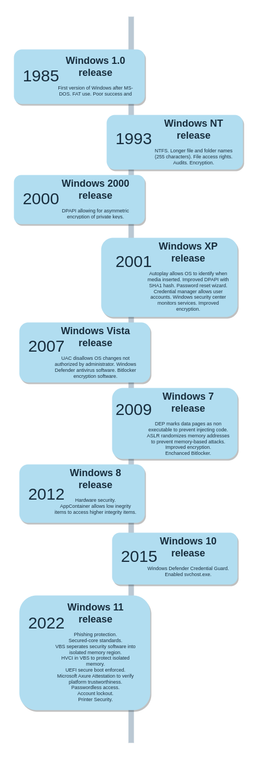Figure 2: Timeline of security features based on [4] [5]
Multiprogramming is when two or more processes are run at the same time. This can be done either through multiple CPUs or using threads.

The need for organization like this or timesharing is more apparent in shared user systems. Windows has specialized OS’ for this such as Windows Server. Each user uses a virtual machine with an indiviual license connecting via RDP and timesharing is controlled by virtual machine managers.

I/O spooling and buffering
In early computers and OS there was the problem that whilst waiting for input/output the CPU would remain idle.

Spooling is a buffer management technique that allows input/output data to be temporarily stored in secondary memory until a process requests the data. This prevents the CPU idle time by allowing other processes to run whilst waiting.

Windows uses virtual memory to help memory management. This allows secondary (disk) memory to be used as additional main memory (RAM) for executable processes.

Buffering is used because the speed of a sender’s (machine or device) transmission may be slower than the reciever’s. In this case the reciever creates a buffer memory space in the main memory and accumulates the bytes sent. This may also happen in reverse.

Comparing Windows to MacOS
MacOS is known for being a secure OS. It uses touchID [3] to replace passwords and encrypt files. Windows has only introduced a similar feature in Windows 11 called Hello Windows which explores passwordless technology such as fingerprint and face recognition. Although this can lock users out at times. Account lockout after failed attempts is also a security feature against remote desktop protocol (RDP) attacks. Windows 11 has specific hardware specifications; requiring at least 2 cores which may limit its availability to some users.

The hardware is also specialized in macOS and requires unique chips, and I/O ports and cables that are only produced by Apple. The chips include security features such as a Boot ROM for secure booting and AES engine space to manage encryption. MacOS also provides XD (execute disable), ASLR (address space layout randomization), and SIP (system integrity protection).

For the file system APFS is designed for SSD storage devices whereas NTFS was designed more for HDD. One major disadvantage of APFS over NTFS is that it does not have data compression. Windows 11 has also started to use the ReFS filesystem which offers more security.

For access control this is defined through the filesystem. Windows uses securable objects and Mac uses keychain items which contain access items which contain multiple ACLs. Mac’s keychain items are things such as passwords which contain an ACL of the apps they can access. Whereas Windows items are apps and contain an ACL that is either a DACL or a SACL (allows administrators to log access attempts) listing all of the ACEs of trustees (accounts) and their permissions of access.

For encryption macOS seems to be superior. It uses FileVault to encrypt the data on the startup disk. This will include a recovery key if the password is forgotten. Windows does not have such a feature unless it is used from a third party.

For processes both Mac and Windows have user terminals and GUI programs to manually monitor processes.

For multiprogramming, macOS uses multiprocessing through POSIX threads. These threads can speed up processing. Windows uses an API based around Events.

For spooling and buffering both OS’ are the same.

Overall it seems that macOS is more secure than Windows, notably because the security is built into the hardware through features such as the custom chips, and thus all aspects are controlled and secured.

Effects on application developers
Application developers can manipulate the functions and security of the operating system using the programming interface provided by Microsoft and invoking system calls to make the kernel perform lower-level functions. For instance, applications can call access control functions that manage access control for resources in the operating system.

Threads are processes that are split into multiple jobs. These jobs run concurrently and have their own stack, program counter, and register but share the same memory. This means threads can share data between themselves without pipes or signals. There are two types of threads: user level, and kernel level. User level threads allow developers to create threads for their programs.
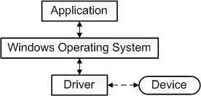Figure 3: Driver diagram [4].

Device drivers are software components that communicate between a device and the operating system to send data to user software. Software drivers can only simply communicate with the operating system to get core operating system data instead of data from a device. Developers can write custom drivers to get access to operating system data or to get data from devices.

Conclusion

Recommendations for hardening the system and OS file systems
To harden the system the recommendations would be as follows. To enable secure boot to protect against malicious code being executed before the boot process. To use improved antivirus monitoring software. To encrypt the host drive using a hardware TPM. Use biometrics or FIDO authentication in addition to secure passwords. And to limit the peripherals that can connect.

Personal reflection
I think that I have completed this work relatively well. I have learnt a lot. I found it very helpful to refer to the recommended text books and documentation. Although it has been challenging to focus on the work because of my poor mental health. To improve I would have made my explanations more succinct, asked others for feedback, and dedicated more space to a conclusion.

Bibliography
1: Javatpoint, What is Kernel?, , https://www.javatpoint.com/what-is-kernel
2: Microsoft, Learn Microsoft Windows Security, 2023, https://learn.microsoft.com/en-us/windows/security
3: Andrew S. Tanenbaum, Albert S. Woodhull, Operating Systems Design and Implementation, 2006,
4: Greg Belding, Windows OS brief history, 2019, https://resources.infosecinstitute.com/topic/windows-os-security-brief-history/
5: Kolide, Windows 11 Security: What You Need to Know (22H2 Update) , , https://www.kolide.com/blog/windows-11-security-what-you-need-to-know-22h2-update
6: Apple, MacOS Documentation, , https://www.apple.com/macos/security/
7: Microsoft, What is a driver?, , https://learn.microsoft.com/en-us/windows-hardware/drivers/gettingstarted/what-is-a-driver-

